Evaluation: ET-OvR
Accuracy: 0.9152970922882427
Precision: 0.9217145573106929
Recall: 0.9152970922882427
F1 Score: 0.9157751069846704
Jaccard Index: 0.8486200079307599
Matthews CorrCoef: 0.8931311221820948
Cohen’s Kappa: 0.8911774851951935
Specificity: 0.9872518990398282
AUC: 0.999784884554711
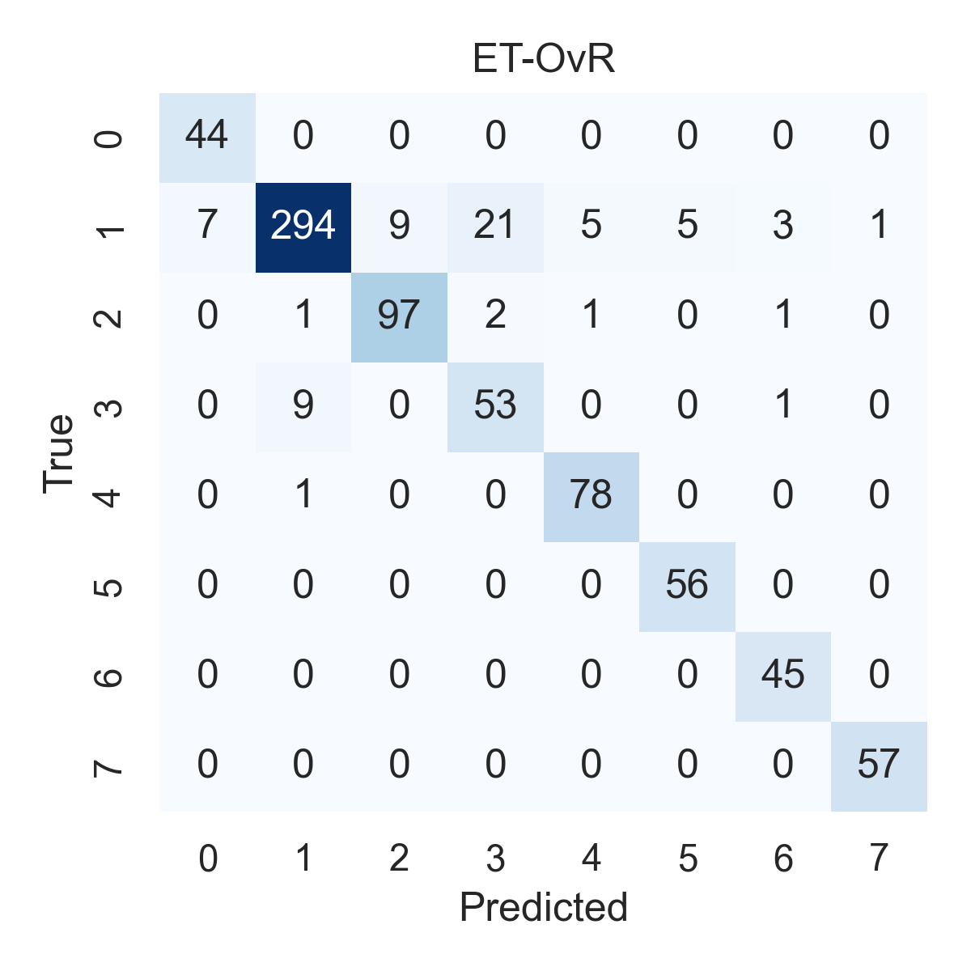

Combined ROC Curves
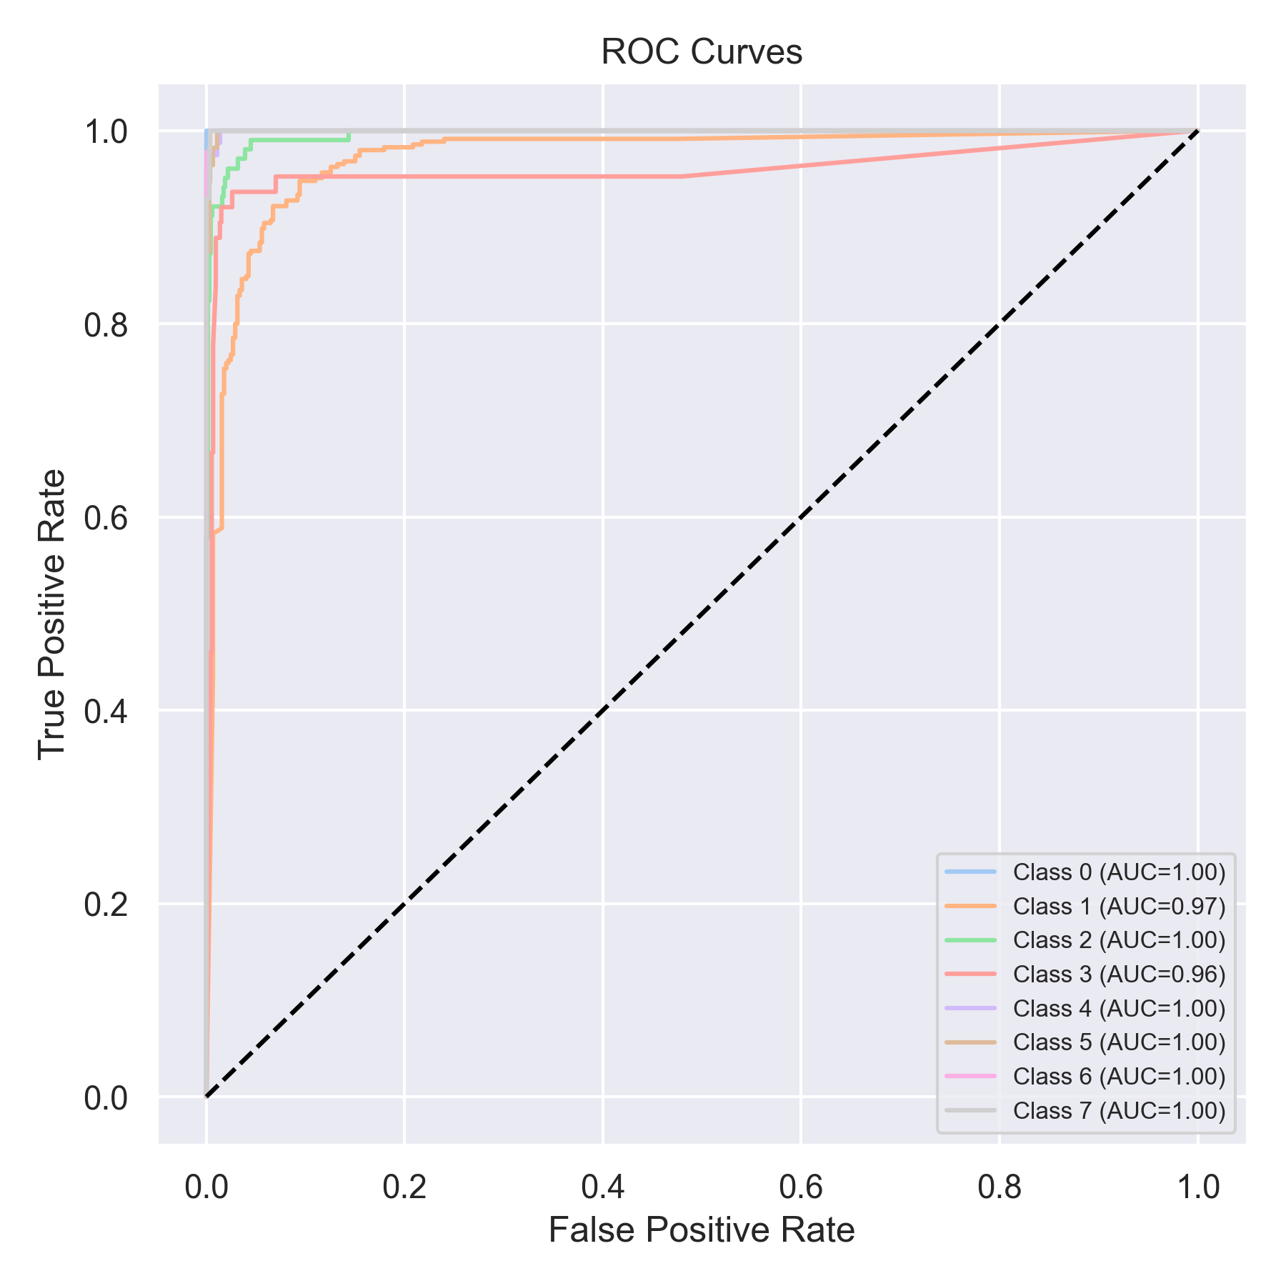

Evaluation: RF-OvR
Accuracy: 0.8975979772439949
Precision: 0.9118017964821281
Recall: 0.8975979772439949
F1 Score: 0.8986006188941649
Jaccard Index: 0.819438988620094
Matthews CorrCoef: 0.8739094992205854
Cohen’s Kappa: 0.869828892780665
Specificity: 0.9852017094820785
AUC: 0.9997131794062813
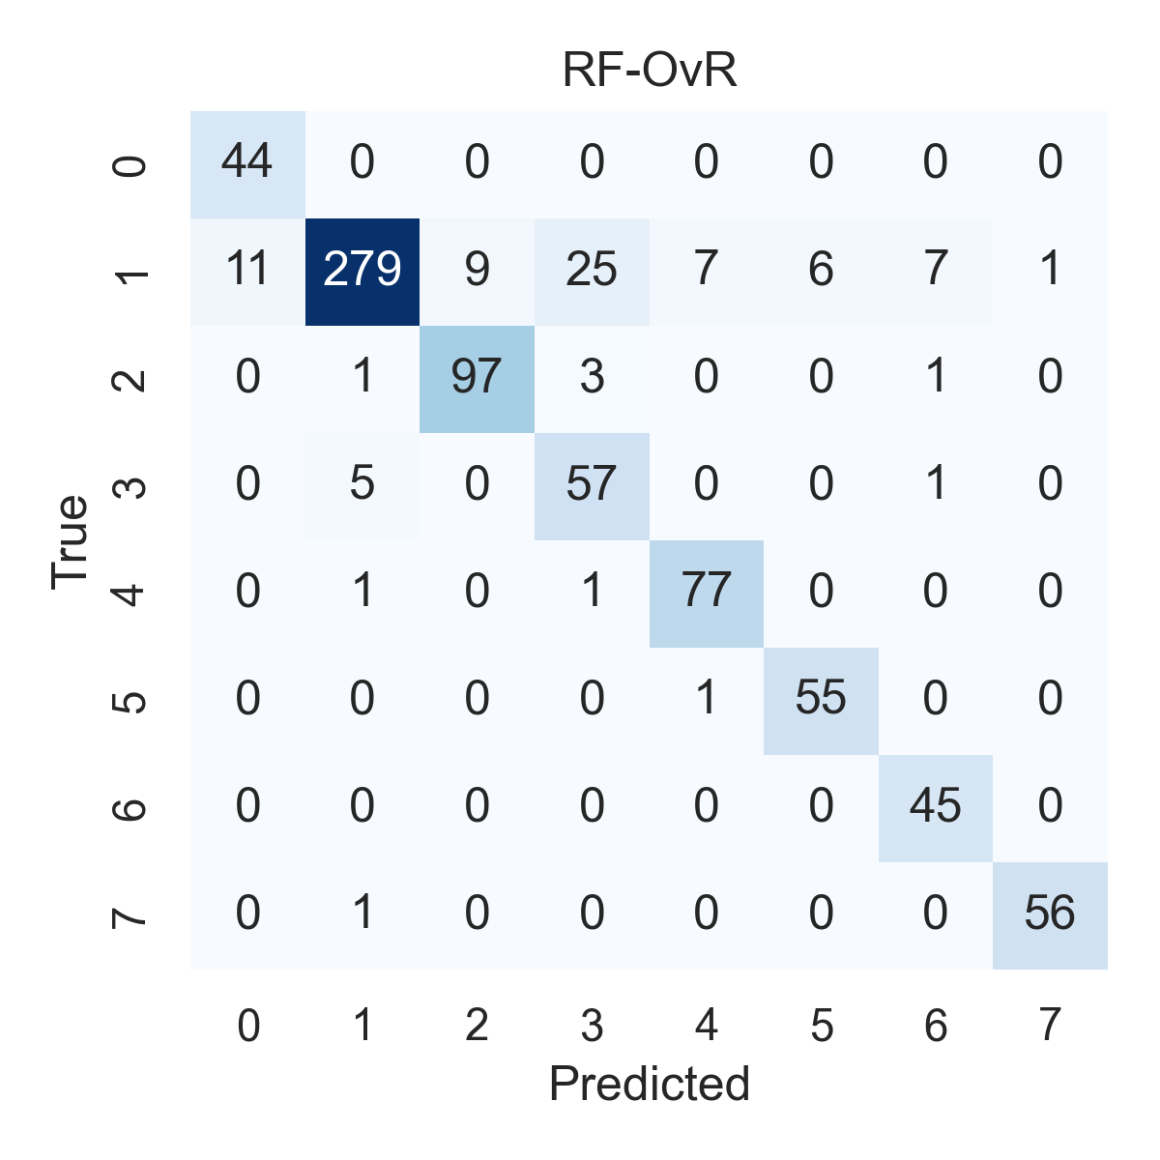

Combined ROC Curves
